Project Logs and Screenshots:

Setting up of my env:

06/17: 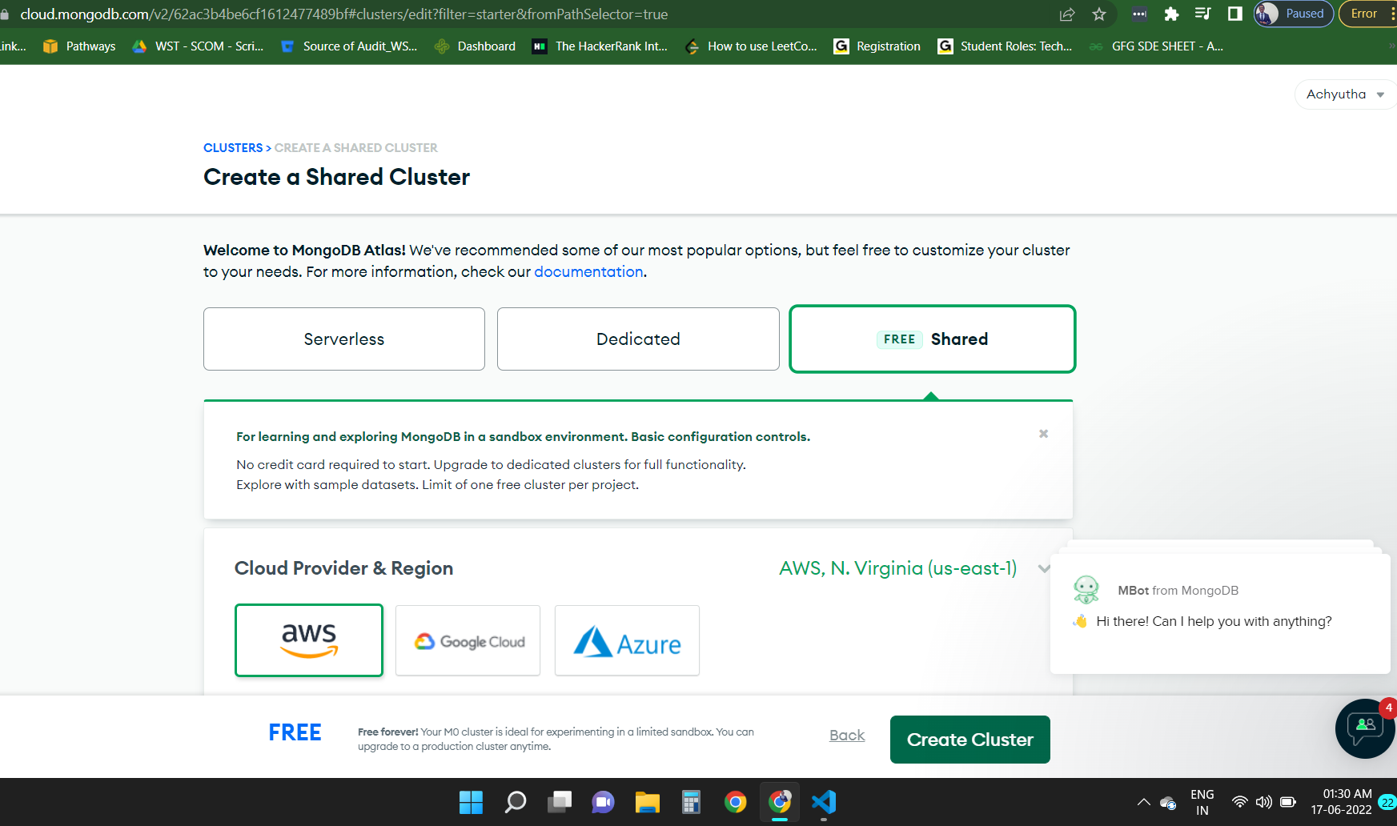

Making a mock json and UI for rendering the required data.

I have not yet created the database and I have hardcoded the tasks just to make sure the UI is working fine.

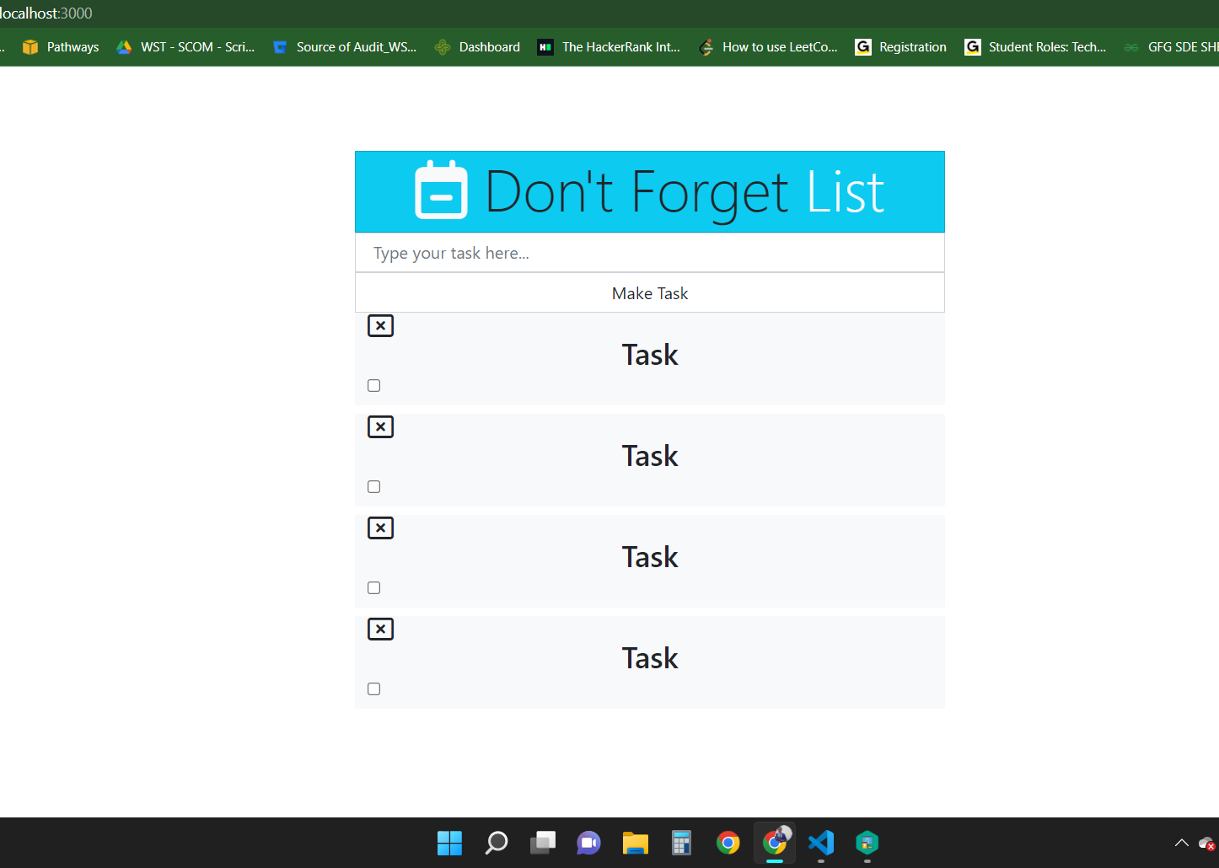

Custom making and hard coding the todo tasks in the UI. Trying to update the schema and start adding some task with titles into the list.

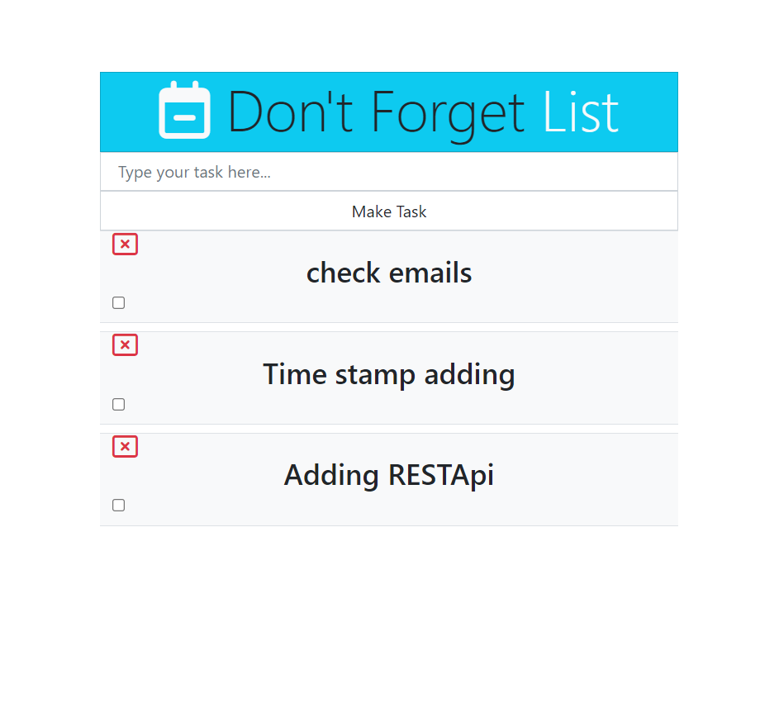

Schema for the Database: (BASIC)

state={

id:4,

title:"",

complete:false

}

Online database setup and hitting the API endpoints :

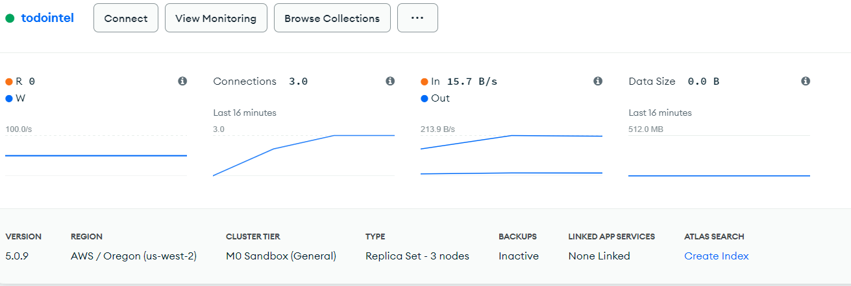

Initial two task already created and the next image takes new task creation:

Also, I would like to name my application as Don’t forget list.

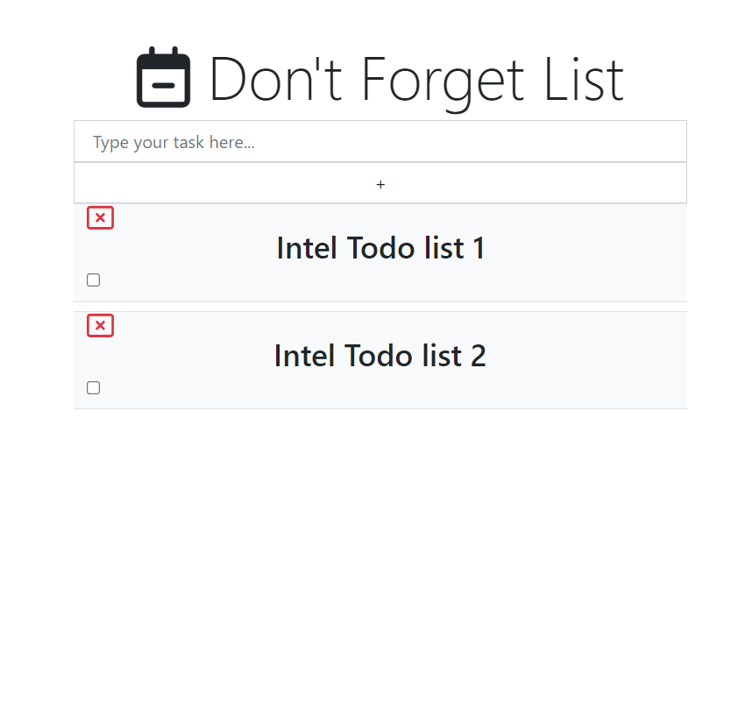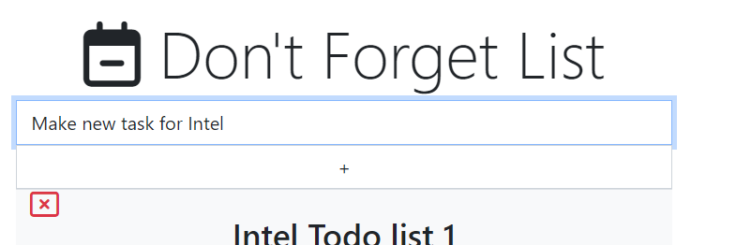

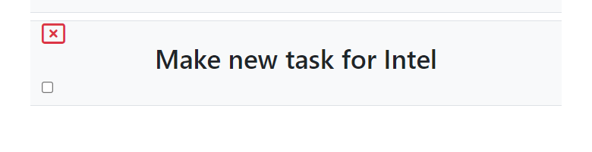

Clicking on the checkbox after the task is completed and modify it if required.

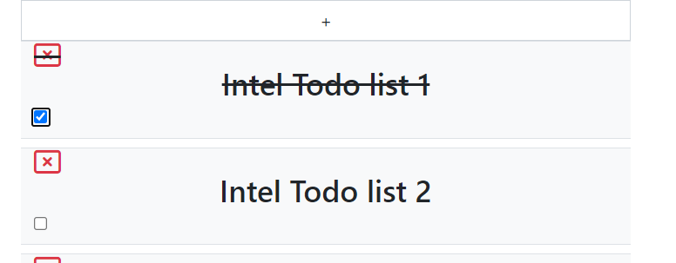

Finally with the help of the close button, you can delete the todo task on the list.

